DESIGN AND IMPLEMENTATION OF A SECURE WEB-BASED E-COMMERCE PLATFORM FOR CALEB UNIVERSITY STUDENTS
CHAPTER ONE
INTRODUCTION
1.1 Background to the Study
The twenty-first century has witnessed a profound transformation in the way people communicate, learn, work, and trade, driven largely by advances in information and communication technology and the spread of the internet (Akande et al., 2024). Among the most significant outcomes of this digital revolution is the rise of electronic commerce, or e-commerce, the buying, selling, and exchange of goods, services, and information over computer networks, principally the internet (Pandey & Gupta, 2023). Unlike traditional commerce, which is confined by physical location and fixed business hours, e-commerce allows transactions at any time and from almost any place, and over the past decade it has grown into one of the most significant channels of modern trade (Rahman et al., 2022).
E-commerce is commonly classified by the parties involved in a transaction, the main models being business-to-business, business-to-consumer, consumer-to-consumer, and consumer-to-business (Saputro et al., 2025). The platform proposed in this study belongs primarily to the consumer-to-consumer category, in which individuals buy from and sell to one another through an intermediary platform whose success depends heavily on the trust it can establish between parties who do not know one another.
A particularly important driver of this growth has been the spread of mobile devices: the widespread ownership of smartphones and affordable mobile data have brought online trade within reach of millions, especially young people, making responsiveness across screens of varying sizes an essential requirement of any modern platform (Ghuge, 2025). This is especially true in Nigeria, whose large and youthful population makes it one of Africa's most promising e-commerce markets; there, the mobile phone is often the primary means of internet access, indigenous platforms such as Jumia and Konga have popularized online shopping, and many small traders reach customers through social media such as WhatsApp and Instagram (Akande et al., 2024).
Despite these gains, the central challenge confronting online trade remains that of trust and security. Because transactions often occur between parties who have never met, buyers must be confident that goods are genuine and will be delivered, while sellers must be assured of payment, and research consistently shows that perceived security and privacy concerns strongly influence whether consumers are willing to buy online (Oguta, 2024). Safeguards such as user authentication, identity verification, and data encryption have therefore become indispensable to any credible platform, which typically combines a front-end interface, a back-end, and a database while protecting users through measures such as password hashing, encrypted connections, and verification of each user's identity before access is granted (Abdul Hussien et al., 2022).
Vibrant economic activity also flourishes within smaller, well-defined communities, of which a university campus is a prime example. Within a typical university, thousands of students live and study in close proximity, generating constant demand for goods such as textbooks, gadgets, and clothing and for services such as tutoring and tailoring, and Nigerian university students in particular actively buy and sell affordable second-hand items among themselves (Giri et al., 2022). At present, however, this campus commerce is conducted largely through informal channels such as word of mouth, notice boards, and social media groups, which are poorly suited to trade: listings cannot be searched or filtered, there is no reliable way to verify the identity or trustworthiness of those involved, and students must often expose personal contact details to unknown members, compromising their privacy (Wei et al., 2023).
Caleb University, a private institution dedicated to academic excellence and the development of its students, is home to just such a lively student community, yet it lacks a dedicated, secure platform through which intra-campus transactions can be conducted. A web-based platform restricted to verified members of the university offers a compelling solution: limiting participation to authenticated students harnesses the trust that is central to online marketplaces, while removing the need for costly delivery logistics since buyers and sellers share the same campus (Mahajan, 2025). It is against this background that the present study seeks to design and implement a secure, web-based e-commerce platform for Caleb University students, replacing the current fragmented and insecure methods of campus trade with a single, trusted, and easy-to-use digital marketplace.
1.2 Statement of the Problem
As commerce shifts increasingly onto digital platforms, the buying and selling of goods and services has become a routine part of everyday economic life, extending well beyond large businesses to the smallest of communities. University campuses are a clear example: within them, thousands of students form an active micro-economy, constantly buying and selling textbooks, gadgets, clothing, and services among themselves. Yet in most institutions this trade is not supported by any dedicated platform, and students rely instead on informal channels such as social media groups, notice boards, and word of mouth (Padwal et al., 2023). These channels are not built for commerce: listings cannot be categorized, searched, or filtered, and a seller's post is quickly buried beneath newer messages, so buyers and sellers struggle to find one another.
This difficulty is felt particularly within private universities, whose campuses function as close, largely self-contained communities in which students depend on one another for many daily needs. In such settings the informal channels currently used provide no way to verify who is taking part: anyone, including non-students, can join, pose as a seller, collect payment, and disappear, leaving victims with little recourse, since perceived risk and weak security are known to undermine trust and discourage online transactions (Shirsat et al., 2022). Students are also required to share personal contact details in public groups and to meet strangers in order to exchange goods, raising clear privacy and safety concerns.
Caleb University is one such private institution, where buying and selling among students is a daily activity yet no secure, dedicated platform exists to support it. Mainstream platforms such as Jumia and Konga do not fill this gap, since they are built for large-scale, long-distance trade with formal delivery and make no provision for the localized, community-based exchange typical of a campus, where much of the trade involves small, low-value, and second-hand items (Vo et al., 2023). The informal channels, for their part, give sellers no tools to manage their listings. There is therefore a clear need for a secure, dedicated platform that restricts access to verified Caleb University students, organizes their listings, and protects all users.
1.3 Aim of the Study
This study aims to design and implement a web-based e-commerce platform.
1.4 Objectives of the Study
The objective of the study are as follows:
i. To investigate the buying and selling needs and behavioural patterns of University students.
ii. To design a responsive, intuitive interface that supports product listing, browsing, searching, and filtering.
iii. To develop an authentication and verification mechanism that restricts platform access to confirmed Caleb University students.
iv. To develop a product management module enabling sellers to create, update, and remove their listings.
v. To evaluate the developed platform's performance, usability, and security.
1.5 Significance of the Study
The successful design and implementation of this platform holds considerable significance for several stakeholders within the university community and beyond. For the general student body, it offers a safe, organized, and convenient marketplace through which to obtain the goods and services required for daily life and academic pursuits. Because access is restricted to verified members of the community, students can transact with far greater confidence than is possible through open social media groups, a benefit that matters because security and trust are repeatedly shown to determine whether consumers are willing to buy online (Low et al., 2024). As goods can often be obtained more cheaply and conveniently from fellow students on the same campus, the platform also saves students both time and money and improves their quality of campus life. The assurance that every other user is a fellow member of the same institution further encourages even cautious students to take part.
To student entrepreneurs and sellers, the platform provides a structured and professional avenue through which to advertise products, reach a wider campus audience, and manage their commercial activity efficiently. The product management module enables sellers to create, update, and remove listings with ease and to build a recognizable presence within the campus market, thereby fostering self-reliance, financial independence, and the kind of digital enterprise that is increasingly central to economic activity in Nigeria (Yuandi et al., 2023). For many students, the platform may serve as a first, low-risk introduction to running an online business, offering experience that is valuable whether or not they pursue commerce after graduation.
To the university administration, the platform contributes to a more connected, organized, and secure campus community by providing an official and trusted channel for student commerce, curbing the proliferation of unregulated trading groups, and reducing the incidence of students being defrauded by outsiders, a risk closely tied to the weak trust and security of informal online dealings (Oguta, 2024). By replacing scattered and unaccountable channels with a single managed system, it also gives the institution a clearer view of, and a measure of oversight over, commercial activity within the campus, and can ease the strain on the informal notice boards and unofficial groups that the institution can neither monitor nor moderate.
Finally, the study contributes to the body of knowledge on secure web application development and on the security measures that shape user trust in e-commerce. The model it presents, a secure, identity-verified marketplace serving a closed community, is readily transferable to other institutions facing similar challenges and serves as a practical reference for researchers and future developers working on trusted, community-restricted systems (Pandey & Gupta, 2023). It thereby adds to the growing body of work on how sound security practices and identity verification can be applied to build confidence in online marketplaces.
1.6 Scope of the Study
Thematically, the study covers the design, implementation, and evaluation of a secure, web-based consumer-to-consumer e-commerce platform restricted to verified students, encompassing secure user registration and authentication, a product management module for creating, editing, updating, and deleting listings, and facilities for browsing, searching, and filtering products by category and price; geographically, it is confined to Caleb University, in Imota, Ikorodu, Lagos State, Nigeria, and is intended exclusively for that institution's verified students; and in terms of time, the work was carried out within a single academic session and draws on contemporary literature published largely between 2021 and 2026 (Ghuge, 2025).
Within the available time, the study focuses on building a secure marketplace that connects verified buyers and sellers and organizes their transactions, with payment handled directly between the parties at the point of exchange. Because all users belong to the same campus and can easily meet in person, this arrangement is both practical and convenient, and it keeps the scope of the platform manageable within the project's timeframe. The integration of a dedicated online payment gateway, which carries additional security and compliance considerations of its own (Low et al., 2024), is therefore identified as a valuable enhancement for future development rather than a core requirement of the present work. In the same way, the study does not extend to the development of native mobile applications for the Android or IOS operating systems, or to users outside the verified Caleb University student community, both of which are noted as possible directions for future improvement.
1.7 Operational Definition of Terms
For the purpose of clarity and consistency, the following terms are defined as they are used within the context of this study:
i. E-Commerce (Electronic Commerce): The buying and selling of goods and services, and the transfer of related information, conducted over electronic networks, principally the internet.
ii. Web Application: A program that runs on a web server and is accessed by users through a web browser, combining a front-end interface with back-end processing.
iii. Consumer-to-Consumer (C2C): A model of e-commerce in which individual consumers buy from and sell to one another, usually through an intermediary platform.
iv. Marketplace: A digital platform that brings together multiple buyers and sellers and facilitates transactions between them.
v. User Authentication: The procedure by which the system confirms that a user is who they claim to be, typically by means of an email address and a password.
vi. Verified Student: A user whose identity as a bona fide member of the Caleb University student community has been confirmed by the system before access to the platform is granted.
vii. Product Management Module: The component of the platform that allows registered sellers to create, view, update, and remove their product listings.
viii. Responsive Design: An approach to web design that ensures a website's layout and content adapt automatically to fit a variety of screen sizes and devices.
ix. Encryption: The process of converting data into a coded form that cannot be read by unauthorized parties, thereby protecting its confidentiality.
x. Security: The collection of measures and safeguards put in place to protect the platform, its data, and its users from unauthorized access, fraud, and other threats.
1.8 Organization of the Study
This study is organized into five chapters. Chapter Oneintroduces the study, presenting the background to the study, the statement of the problem, the aim and objectives, the significance of the study, the scope of the study, the operational definition of terms, and the organization of the study. Chapter Two reviews the relevant literature and identifies the gaps that the study seeks to address. Chapter Three presents the research methodology, system analysis, and system design, including the architecture, database, and interface design of the platform. Chapter Four deals with the implementation, testing, and evaluation of the platform, and Chapter Five presents the summary, conclusion, and recommendations arising from the study.

CHAPTER TWO
LITERATURE REVIEW
2.1 Preamble
The preceding chapter established the background, problem, aim, and objectives of this study, which is centered on the design and implementation of a secure, web-based e-commerce platform for Caleb University students. This chapter builds on that foundation by reviewing the relevant literature, in order to situate the study within the broader context of electronic commerce, web application development, and campus-based digital marketplaces, and to expose the gaps that justify the present contribution. The review is organized into four broad parts: a conceptual review of the concept and evolution of e-commerce, its principal models and their relevance to campus marketplaces, e-commerce adoption in Nigeria and within the university context, user authentication, and online order handling; a theoretical framework drawing upon the Technology Acceptance Model, the principles of usability and user-centered design, and the principles of web application security; an empirical review of existing commercial platforms, campus and university-based marketplace systems, and related student and academic projects; and, finally, a synthesis of the insights gained and the research gaps the present study seeks to address.
2.2 Conceptual Review
This section reviews the central concepts upon which the study rests. It begins by tracing the concept and development of e-commerce, proceeds to examine the various models of e-commerce and their applicability to a campus setting, and then considers the adoption of e-commerce in Nigeria and within the university environment. It concludes by discussing two functional concepts that are particularly pertinent to the proposed platform, namely user authentication for restricting access to a verified community, and the handling of online orders through checkout and simulated checkout processes
2.2.1 Concept and Evolution of E-Commerce
Electronic commerce, commonly abbreviated as e-commerce, refers to the buying, selling, and exchange of products, services, and information conducted over computer networks, principally the internet (Rahman, Khan, & Islam, 2022; Pandey & Gupta, 2023). Although the term is frequently associated in popular usage with online retail alone, it extends to a far wider range of activities, including electronic payments, internet banking, digital advertising, online auctions, and the operation of digital marketplaces that bring together numerous buyers and sellers within a single platform (Akande et al., 2024). The defining feature of e-commerce is that the commercial process, or a substantial part of it, is mediated electronically, with the consequence that transactions are freed from the constraints of physical location and fixed operating hours that bind conventional trade.
The development of e-commerce has proceeded in step with the advance of internet technologies. Its earliest foundations lay in mechanisms for the electronic exchange of business documents and the electronic transfer of funds, which were largely confined to large corporations operating over private networks (Pandey & Gupta, 2023). The commercialization of the internet and the emergence of the World Wide Web subsequently opened electronic commerce to the general public and gave rise to the online stores and marketplaces whose basic template, comprising product catalogues, shopping carts, and online payment, persists to this day (Rahman et al., 2022). More recent waves of innovation, including the spread of broadband and mobile connectivity, the development of secure payment systems, and the introduction of personalization technologies, have transformed online shopping from a novelty into a routine activity (Saputro et al., 2025), and a steady stream of recent studies attests to the continued expansion of e-commerce and to its adoption across an ever-widening range of contexts (Pandey & Gupta, 2023).
The proliferation of e-commerce has been driven by, and has in turn reinforced, a range of benefits that accrue to its various participants. For sellers, it reduces the overhead costs associated with operating a physical store, extends market reach beyond the limits of geography, and permits trading to continue around the clock without regard to conventional business hours (Pandey & Gupta, 2023). For buyers, it offers convenience, a wider variety of choice, the ability to compare products and prices with ease, and access to goods and services that might not be available locally (Rahman et al., 2022). At the level of the wider economy, e-commerce lowers the barriers to entry for small enterprises and individual entrepreneurs, fosters competition, and contributes to the growth of allied sectors such as logistics, digital payments, and financial technology. These benefits are not confined to large-scale commerce; they are equally available, in proportionate measure, to the participants in a small community marketplace, where the reduction of search costs and the widening of reach are of direct and tangible value to students seeking to buy from and sell to one another.
A development of particular consequence for the present study is the rise of mobile commerce, the conduct of commercial transactions through mobile devices such as smartphones and tablets. The widespread ownership of smartphones, together with increasingly affordable mobile data, has extended the reach of e-commerce to populations that might never have owned a personal computer, and it has made the mobile device the primary means by which many users, and young users in particular, engage in online activity. This shift carries profound implications for the design of e-commerce platforms, which must now function comfortably on small touch-screen displays as well as on conventional computers; the recurring concern of recent design studies with accessible and adaptable interfaces is in large part a response to this reality (Saputro et al., 2025; Ghuge, 2025).
From a technical standpoint, an e-commerce platform is typically realized as a web application composed of several interacting layers. A front-end, or client side, presents the user interface through which buyers and sellers interact with the system in their browsers; a back-end, or server side, houses the business logic that processes requests, enforces rules, and manages transactions; and a database stores the persistent data of the system, such as user accounts, product listings, and order records. Recent studies of e-commerce design and implementation describe this layered architecture in detail and demonstrate how the separation of presentation, logic, and data contributes to systems that are easier to develop, to maintain, and to secure (Rahman et al., 2022; Pandey & Gupta, 2023; Saputro et al., 2025). An appreciation of this architecture is essential to the present study, since the platform it proposes must integrate a responsive interface, a secure processing layer, and a reliable data store into a coherent whole.
For the purposes of the present study, two observations arising from this conceptual overview are particularly significant. The first is that e-commerce is not a monolithic phenomenon but a broad family of activities and arrangements that can be tailored to the specific needs of different communities and contexts. The second is that the trajectory of e-commerce has been one of progressively widening access, moving from large corporations to the general public, and from desktop computers to mobile devices (Giri et al., 2022; Mahajan, 2025). A platform designed for a specific community such as a university campus, and optimized for the mobile devices that its members predominantly use, therefore represents a natural and timely application of the principles and technologies that this evolution has produced.
2.2.2 Models of E-Commerce (B2C, C2C, B2B) and Their Relevance to Campus Marketplaces
E-commerce encompasses a broad field of activity that is conventionally classified into a number of distinct models, distinguished principally by the nature of the parties that participate in a transaction (Akande et al., 2024). For the purposes of this study, the three most relevant models are the following:
i. Business-to-Consumer (B2C): This model describes transactions in which a business sells goods or services directly to individual consumers. It is the model most familiar to the ordinary online shopper and is exemplified by online retailers that maintain their own inventory and sell to the public. B2C transactions typically involve relatively low individual values, short decision cycles, and a large number of customers (Akande et al., 2024).
ii. Business-to-Business (B2B): This model describes transactions between two business entities, such as a manufacturer selling to a wholesaler or a wholesaler selling to a retailer. B2B commerce is characterized by larger transaction values, longer-term relationships, bulk ordering, and more complex negotiation and procurement processes than its B2C counterpart (Akande et al., 2024).
iii. Consumer-to-Consumer (C2C): This model describes transactions conducted directly between individual consumers, who act in turn as buyers and as sellers, typically through an intermediary platform that brings them together and provides the tools necessary to facilitate their exchanges. C2C commerce encompasses a wide variety of goods and services, ranging from second-hand items to crafts and personal services, and it grants participants considerable freedom to set their own prices and terms (Mahajan, 2025; Wei et al., 2023).
The consumer-to-consumer model is of particular importance to the present study, for it most closely describes the pattern of trade that takes place within a university campus. In a campus marketplace, the same individuals are at different times buyers and sellers; a student may sell a used textbook one week and purchase a mobile phone accessory the next. The platform itself does not own the goods being traded but functions as an intermediary that establishes a digital space in which buyers and sellers can find one another and transact. This pattern is precisely the one addressed by a growing body of recent work on campus and student marketplaces, in which platforms are built to enable students to trade goods, and especially second-hand goods, directly with their peers (Giri et al., 2022; Wei et al., 2023; Mahajan, 2025).
Within the consumer-to-consumer model, the intermediary platform performs several indispensable functions beyond the mere listing of goods. It provides the search and categorization facilities through which buyers locate items of interest, the channels through which the parties to a transaction coordinate, and, crucially, the trust and safety mechanisms that lend confidence to exchanges between individuals. On large public platforms these mechanisms have historically taken the form of buyer and seller ratings, reputation scores, and intermediated payment; in the campus context, recent studies have shown that such mechanisms can be complemented, or in part replaced, by the verification of membership and by features designed expressly to foster safety and trust among student users (Mahajan, 2025; Wei et al., 2023).
A recurring challenge of the C2C model is the problem of trust, since transactions take place between individuals rather than with an established business. The proposed platform for Caleb University students, being a consumer-to-consumer marketplace operating within a closed and well-defined community, is distinctively well placed to address this challenge. Whereas general-purpose C2C platforms must contend with the anonymity of participants drawn from the wider public, a campus marketplace can substitute community membership for anonymity: by restricting participation to verified members of the same institution, the platform replaces reputation built over many transactions with the inherent accountability of a shared and bounded community. The model is thus the same as that of the large commercial platforms, but the closed nature of the community confers a distinctive advantage with respect to trust and security, which is one of the central themes of this study and of recent campus-marketplace research (Mahajan, 2025; Padwal, Punde, Ghadge, & Sahu, 2023).
2.2.3 E-Commerce Adoption in Nigeria and the University Context
Nigeria has emerged as one of the most significant markets for electronic commerce on the African continent. With a population exceeding two hundred million, a predominantly youthful demographic, rising internet penetration, and rapidly increasing smartphone adoption, the country presents a large and growing market for online trade, and recent work on the design and implementation of e-commerce marketplaces in the Nigerian setting reflects the vitality of this sector (Akande et al., 2024). The adoption of e-commerce in Nigeria has been further accelerated by changing consumer habits, particularly in the wake of the COVID-19 pandemic, which moved online shopping from a convenience to a necessity for many consumers.
Notwithstanding this growth, the literature consistently identifies trust and security as central determinants of e-commerce adoption. Because online transactions frequently take place between parties who have never met, consumers must be confident that the goods advertised are genuine, that they will receive what they pay for, and that their personal and financial information will be protected; where this confidence is lacking, adoption is impeded (Oguta, 2024). Studies that examine the security and privacy challenges of the virtual marketplace consistently report that concerns over fraud, data breaches, and the misuse of personal information remain among the most serious obstacles to the fuller embrace of online commerce (Oguta, 2024). These findings imply that, in any context, the success of an e-commerce initiative depends not only on the technical quality of the platform but also on the degree to which it is able to inspire confidence and mitigate the risks that users perceive.
Beyond the question of trust, the literature on e-commerce in developing economies draws attention to a range of infrastructural and contextual challenges that shape the prospects of any online platform (Akande et al., 2024). These include the reliability of electric power and internet connectivity, the cost and accessibility of the technology on which both merchants and consumers depend, the maturity of the digital payment and delivery infrastructure, and the strength of the legal and regulatory frameworks that govern online transactions and protect consumers (Oguta, 2024). Studies concerned with the implementation of e-commerce systems and with the security of the virtual marketplace situate their technical proposals against the backdrop of these wider conditions (Rahman et al., 2022; Abdul Hussien et al., 2022).
For a platform confined to a single university campus, several of these challenges are mitigated by the very nature of the setting: connectivity within the campus is often comparatively reliable, the parties to a transaction are physically close to one another, and the bounded community greatly simplifies questions of trust and accountability.
Within the university context, these general observations acquire a particular character. University students constitute one of the most dynamic and digitally engaged segments of the population; they are typically comfortable with technology, are heavy users of smartphones and social media, and engage in frequent buying and selling among themselves. Recent research has accordingly turned its attention to e-commerce solutions aimed specifically at students, including platforms intended to cultivate a digital-economy and entrepreneurial mindset among the student population (Yuandi, Kahar, & Purnama, 2023) and models that integrate e-commerce into the wider apparatus of student management (Vo, Nguyen, Ta, & Dinh, 2023). This emerging literature confirms both that students are a receptive user base for e-commerce and that there is a recognized need for platforms designed around their particular circumstances.
The combination of a highly receptive user base and the absence, in many institutions, of an appropriate and trustworthy platform creates a clear opportunity for a campus-specific solution. Crucially, the trust deficit that constrains e-commerce adoption in the wider market can be substantially reduced within a university setting, where participation can be confined to verified members of a single, accountable community (Oguta, 2024; Yuandi et al., 2023). The proposed platform for Caleb University students is conceived precisely to exploit this opportunity, addressing at the level of design the very concern, namely trust and security that the literature identifies as most critical to adoption.
2.2.4 User Authentication and Restricting Access to Verified Student Communities
Authentication is the process by which a system verifies that a user is genuinely who they claim to be, and it is a foundational requirement of any secure web application (Low et al., 2024). It is conceptually distinct from, though closely linked to, identification, which is the act of a user asserting an identity, and authorization, which is the subsequent process of determining what an authenticated user is permitted to do. Authentication mechanisms are traditionally classified according to the factors on which they rely: something the user knows, such as a password; something the user possesses, such as a mobile device or security token; and something the user is, such as a fingerprint or other biometric characteristic. The combination of two or more of these factors, known as multi-factor authentication, provides a substantially higher level of assurance than reliance on any single factor alone, and the importance of robust authentication has been emphasized repeatedly in recent work on secure e-commerce systems (Abdul Hussien et al., 2022).
The most widely used authentication mechanism remains the password, by which a user proves their identity through knowledge of a secret credential. Because the compromise of stored passwords represents a serious security risk, established practice requires that passwords never be stored in plain text but instead be transformed through a one-way cryptographic hashing function, so that the original password cannot be recovered even if the stored values are exposed (Oguta, 2024). Recent studies of secure e-commerce design devote considerable attention to such measures, presenting secure prototype structures and secured exchange platforms in which authentication, encryption, and the careful management of user sessions are treated as central rather than incidental concerns (Abdul Hussien et al., 2022; Shirsat et al., 2022).
For a platform intended to serve a specific and bounded community, authentication assumes an additional and distinctive role: it becomes the means by which access is restricted to verified members of that community. The most common technique for achieving such restriction is verification through an institutional email address, by which prospective users are required to register with, and to confirm ownership of, an email address belonging to the institution's domain, so that only genuine members of the community are admitted (Giri et al., 2022). The concern with verifying the identity of student participants and securing their interactions runs through much of the recent campus-marketplace literature, and more advanced proposals have gone so far as to employ emerging technologies such as block-chain to provide tamper-resistant records of student identity and activity (Vo et al., 2023). Recurring throughout this body of work is the recognition that secure identity management is the foundation upon which trust in a student-oriented platform is built (Mahajan, 2025; Padwal et al., 2023). Authentication is, moreover, only the first element of a broader system of access control. Once a user's identity has been established, the platform must determine what that user is permitted to do, a function known as authorization. In a marketplace, different categories of user require different privileges: an ordinary member may browse listings and place orders; a member acting as a seller must additionally be able to create and manage their own listings; and an administrator may require still broader powers to oversee the system. The principle of least privilege, by which each user is granted only the access necessary for their legitimate purposes, is widely regarded as a cornerstone of secure design, and recent studies of secure e-commerce and exchange platforms incorporate such role-based access control alongside authentication and the careful management of user sessions (Shirsat et al., 2022; Low et al., 2024).
This mechanism is directly pertinent to the present study, whose objectives include the implementation of a secure authentication system that restricts access to verified Caleb University students. By combining sound general authentication practice, such as the secure hashing of passwords and the careful management of sessions, with a verification process tied to the university community, the proposed platform aims to realize the dual goal of protecting individual user accounts and preserving the closed character of the marketplace. In doing so, it operationalizes at the level of system design the insight, drawn from the wider literature, that trust and security are decisive determinants of adoption: the verification of student identity is not merely a technical control but the very foundation of the trust on which the platform depends (Oguta, 2024).

2.2.5 Online Order Processing and Simulated Checkout Systems
Once a buyer has located a desired product within an e-commerce platform, the transaction proceeds through a sequence of steps commonly referred to as the order processing or checkout process. In a typical implementation, the buyer first adds the chosen items to a virtual shopping cart, a software construct that holds the selected products and their quantities pending purchase; the buyer then proceeds to checkout, at which stage the system collects the information necessary to complete the transaction before generating an order record that can be tracked by both parties (Ghuge, 2025). The shopping cart and checkout subsystem is therefore responsible for translating a user's intention to buy into a structured and persistent record of a transaction, and recent work on online shopping systems has sought to make this process as efficient and frictionless as possible (Ghuge, 2025; Pandey & Gupta, 2023).
In full-scale commercial platforms, the checkout process is integrated with an online payment gateway, a service that securely handles the transfer of funds from the buyer to the seller. The integration of a live payment gateway introduces significant additional requirements relating to financial security, regulatory compliance, and the protection of sensitive payment data, and it typically depends on commercial agreements with the relevant providers. For prototypes, academic projects, and platforms that serve closed communities in which goods are exchanged in person, a simulated or mock checkout process is frequently adopted in place of a live payment integration (Rahman et al., 2022; Saputro et al., 2025).
A simulated checkout reproduces the structure and flow of a genuine checkout, allowing the buyer to confirm an order and the system to generate and store the corresponding order record, but it does not effect an actual transfer of funds; instead, payment is either represented symbolically within the system or completed outside it through arrangements made directly between the parties. This approach allows the order management functionality of a platform to be designed, demonstrated, and evaluated in full without the considerable overhead and risk associated with handling real financial transactions, and it is well suited to a campus marketplace in which buyers and sellers, being physically co-located, can conveniently settle payment in person (Rahman et al., 2022; Saputro et al., 2025).
The checkout process does not operate in isolation but forms the culmination of a sequence of activities that the platform must support. Before a purchase can be made, the seller must be able to create and manage product listings, and the buyer must be able to discover them; the product management module and the search and filtering facilities are therefore as integral to the transaction flow as the checkout itself. Recent work on online shopping systems treats these functions as a connected whole, emphasizing that an efficient and satisfying purchase experience depends upon the smooth interaction of product discovery, cart management, and order processing (Ghuge, 2025; Pandey & Gupta, 2023).
The order record generated at checkout typically passes through a sequence of states over the course of its lifetime, such as pending, confirmed, completed, or cancelled, and a well-designed order management subsystem allows both buyers and sellers to view and, where appropriate, to update the status of their orders (Ghuge, 2025). The maintenance of such structured and persistent order records confers several advantages over the informal arrangements that prevail in unstructured channels: it provides each party with a clear and durable account of what has been agreed, it enables sellers to keep track of their sales, and it furnishes a basis for any subsequent communication or dispute resolution. The relevance of this concept to the present study follows directly from the scope defined in the preceding chapter: the proposed platform is conceived primarily as a marketplace that connects buyers and sellers within the campus, with payment expected to take place in person and with the integration of a full online payment gateway reserved as a possibility for future enhancement. A simulated checkout process therefore represents the appropriate design choice, enabling students to place and manage orders in a structured manner while deferring the additional complexity of live payment processing.
2.3 Theoretical Framework
A theoretical framework provides the lens through which a study interprets its problem and grounds its design and evaluation in established bodies of knowledge (DeLone & McLean, 2003). The present study draws upon three complementary theoretical perspectives. The first, the DeLone and McLean Information Systems Success Model explains the factors that determine whether an information system delivers genuine value to its users and the organization it serves. The second, the body of principles surrounding usability and user-centered design informs the creation of an interface that students will find easy and satisfying to use (Nielsen, 1994). The third, the principles of web application security articulated through the confidentiality, integrity, and availability triad, guides the protection of the platform and its users (Oguta, 2024).
Together, these perspectives address the three pillars of a successful e-commerce platform, namely system success, usability, and security, which correspond closely to the objectives of this study.
2.3.1 DeLone and McLean Information Systems Success Model
The DeLone and McLean Information Systems Success Model, first proposed in 1992 and subsequently updated in 2003, is one of the most widely cited and applied frameworks for measuring and explaining the success of information systems (DeLone & McLean, 2003). The model was developed in response to the challenge of defining and operationalizing what it means for an information system to succeed, a question that had resisted straightforward answer given the many dimensions along which a system may be judged (DeLone & McLean, 1992). The updated model identifies six interrelated dimensions of success: information quality, system quality, service quality, use and intention to use, user satisfaction, and net benefits (DeLone & McLean, 2003).
Information quality refers to the characteristics of the output that a system produces, encompassing attributes such as accuracy, completeness, relevance, and timeliness (DeLone & McLean, 2003). System quality refers to the technical properties of the system itself, including its ease of use, reliability, availability, and response time. Service quality refers to the quality of support that the system's operators provide to its users, reflecting dimensions such as responsiveness, assurance, and empathy (DeLone & McLean, 2003). These three quality dimensions collectively influence use and user satisfaction, which in turn produce net benefits at the individual and organizational level (DeLone & McLean, 2003). The dimensions are understood to be interdependent rather than independent: a system of high technical quality but poor information quality will not fully satisfy users, just as high-quality information delivered through an unreliable system will fail to realize its potential value (DeLone & McLean, 1992; DeLone & McLean, 2003).
The model has been widely applied in e-commerce research, where its dimensions map naturally onto the concerns of online platforms. Researchers have used it to evaluate B2C and C2C systems, examining how improvements in information quality, system quality, and service quality translate into greater user satisfaction, continued use, and ultimately measurable benefits for buyers, sellers, and the platform operator (DeLone & McLean, 2003).

The relevance of the DeLone and McLean model (2003) to the present study is direct and substantial. The success of the proposed campus marketplace platform cannot be judged by its technical construction alone; it must be assessed across the full range of dimensions the model identifies (DeLone & McLean, 2003). The information quality dimension motivates careful attention to how product listings are structured and presented, ensuring that students can access accurate, complete, and relevant information when making purchasing decisions. The system quality dimension underpins the study's objective of building a reliable, responsive, and accessible platform. The service quality dimension speaks to the mechanisms through which students can seek assistance and resolve problems. Use and user satisfaction, in turn, provide the evaluative criteria against which the platform's performance is ultimately measured, while net benefits in the form of safer, more convenient, and more efficient trade among students constitute the overarching goal the study seeks to achieve (DeLone & McLean, 2003).
2.3.2 Principles of Usability and User-Centered Design
Closely allied to the question of technology acceptance is the discipline of usability, which is concerned with the ease and effectiveness with which users are able to accomplish their goals when interacting with a system. Usability is widely regarded as a critical quality attribute of any interactive system, and it is especially crucial for websites and web applications, where users who encounter difficulty or confusion can abandon a service with a single click. Nielsen (1994) characterized usability in terms of components such as learnability, the ease with which new users can accomplish basic tasks; efficiency, the speed with which experienced users can perform tasks; memorability, the ease with which users can re-establish proficiency after a period of disuse; the frequency and severity of the errors that users make; and the subjective satisfaction that users derive from the system.
Perhaps the most widely used practical framework for evaluating and improving usability is the set of ten usability heuristics formulated by Nielsen (1994). These heuristics, deliberately framed as broad rules of thumb rather than rigid rules, include such principles as the visibility of system status, whereby the design keeps users informed about what is happening through timely feedback; the match between the system and the real world, whereby the system speaks the users' language; user control and freedom; consistency and adherence to established conventions; error prevention; recognition rather than recall, whereby information is made visible so that users need not strain their memories; flexibility and efficiency of use; aesthetic and minimalist design; help for users in recognizing and recovering from errors; and the provision of help and documentation. Although developed several decades ago, these heuristics have proved remarkably durable and continue to provide a practical checklist for the design and evaluation of interfaces (Nielsen, 1994).
The heuristics of Nielsen are situated within the broader philosophy of user-centered design, associated above all with the work of Norman (2013), which holds that systems should be designed around the needs, capabilities, and limitations of their users rather than around the convenience of the designers or the constraints of the underlying technology. Norman (2013) argued that the difficulty of using a poorly designed product is a failure of design rather than a failure of the user, and he articulated principles such as making the possible actions at any moment visible and intuitive, providing clear feedback on the results of actions, and establishing natural mappings between intended outcomes and the actions required to achieve them. The enduring influence of this philosophy is evident in the recurring emphasis, across recent studies of e-commerce design and implementation, upon the creation of user-friendly, responsive, and intuitive interfaces as a precondition of a successful system (Pandey & Gupta, 2023; Saputro et al., 2025; Ghuge, 2025).
A consideration of particular importance for contemporary web applications, and one closely bound up with usability, is responsive design, the practice of constructing interfaces that adapt automatically to the wide range of screen sizes and devices through which users may access a system. Because students access online services predominantly through smartphones, an interface that is awkward or unusable on a small screen will fail the very users it is intended to serve, however well it may perform on a desktop computer. The emphasis that recent studies of e-commerce design place upon user-friendly and accessible interfaces reflects an awareness of this imperative (Saputro et al., 2025; Ghuge, 2025), and responsive design may be understood as the practical expression, in the setting of a multi-device world, of the user-centered philosophy that this section has described.
For the present study, the principles of usability and user-centered design provide both a guide to the design of the platform's interface and a basis for its evaluation. The study's second objective, the design of a user-friendly and responsive interface that allows students to browse, list, search, and filter products with ease, is in essence a commitment to usability, and the heuristics of Nielsen (1994) together with the design philosophy of Norman (2013) furnish concrete guidance for fulfilling that commitment. These same principles inform the usability dimension of the study's fourth objective, the evaluation of the platform. There is, moreover, a clear connection between usability and acceptance: in the language of the Technology Acceptance Model, attention to usability is precisely the means by which a designer enhances the perceived ease of use that the model identifies as a determinant of adoption.
2.3.3 Principles of Web Application Security (Confidentiality, Integrity, Availability)
Security is a defining requirement of the platform proposed in this study, as reflected in its very title, and the principles of web application security therefore constitute an essential component of its theoretical framework. The foundational model of information security is the so-called CIA triad, which holds that the security of information rests upon three interdependent pillars, namely confidentiality, integrity, and availability. The triad provides a concise and widely accepted framework for reasoning about security requirements and threats, and it serves as a starting point for the design of security measures in any system that handles valuable or sensitive data; its continuing relevance is reflected in recent surveys of the security and privacy challenges that confront the virtual marketplace (Oguta, 2024).
The three pillars of the triad may be described as follows:
i. Confidentiality is the principle that information should be accessible only to those who are authorized to access it, and that it should be protected from disclosure to unauthorized parties. In the context of a web application, confidentiality is upheld through measures such as access control, the encryption of data, and the secure handling of credentials, so that personal information and account details are not exposed to those who have no right to see them.
ii. Integrity is the principle that information should remain accurate, complete, and trustworthy, and that it should be protected from unauthorized or accidental alteration. Integrity encompasses both the assurance that data has not been improperly changed and the assurance that it originates from a legitimate source; it is supported by measures such as input validation, access control, and audit trails that record changes to data.
iii. Availability is the principle that information and the services that provide access to it should be reliably accessible to authorized users when required. Availability is protected through measures such as the maintenance of reliable infrastructure, the management of system load, and the implementation of safeguards against the attacks and failures that would otherwise disrupt access to the system.
The application of these principles to a web platform depends, in the first instance, upon the secure transmission of data between users and the server. The use of encrypted communication, by which information exchanged between a browser and a server is rendered unintelligible to any party that might intercept it, is now regarded as a basic requirement for any system that handles personal information or credentials, and it underpins both the confidentiality and the integrity that the triad demands. Recent work on secure e-commerce accordingly treats encryption, both of data in transit and of sensitive data at rest, as an indispensable foundation upon which higher-level protections are built (Low et al., 2024; Abdul Hussien et al., 2022).
The triad is frequently extended with the closely related concepts of authentication, authorization, and auditing, since the confidentiality and integrity of sensitive data cannot be assured without reliable means of verifying user identity and controlling user access. Recent work on secure e-commerce systems has translated these abstract principles into concrete design practice, presenting secure prototype structures, secured exchange platforms, and secure web applications in which encryption, access control, and the validation of user input are employed to defend against the common categories of attack to which e-commerce systems are exposed (Abdul Hussien et al., 2022; Shirsat et al., 2022; Low et al., 2024). Studies dedicated specifically to the security and privacy of the virtual marketplace further catalogue the threats that such systems must anticipate, ranging from the interception and theft of data to fraud and the unauthorized manipulation of records, and they underscore that security must be designed into a platform from the outset rather than added as an afterthought (Oguta, 2024).
An understanding of the principles of security is most useful when set against an awareness of the specific threats that web applications face. Among the most commonly encountered are injection attacks, in which malicious input is supplied to a system in an attempt to subvert its behavior or to extract data it should not reveal; the compromise of weak or improperly managed authentication and session mechanisms; the unauthorized execution of scripts within users' browsers; and the interception of data transmitted between the client and the server. Studies of secure e-commerce design address these threats through measures such as the validation and sanitization of user input, the secure hashing of credentials, the encryption of data in transit, and the disciplined management of sessions (Abdul Hussien et al., 2022; Low et al., 2024; Oguta, 2024). The value of cataloguing such threats lies in the direction it gives to the designer's attention, focusing effort upon the points at which systems are most often compromised.
These principles bear directly upon the third objective of the present study, the implementation of a secure authentication system and product management module, and upon the security dimension of its fourth objective, the evaluation of the platform. The CIA triad supplies the conceptual vocabulary in which the platform's security requirements can be articulated: confidentiality demands that students' personal information and credentials be protected; integrity demands that product listings and account data be safeguarded against unauthorized alteration; and availability demands that the marketplace remain reliably accessible to its users. The body of recent secure-e-commerce research, in turn, provides a practical guide to the measures by which these requirements may be met (Abdul Hussien et al., 2022; Low et al., 2024). In grounding the study in these established principles, the framework ensures that the platform's security is approached systematically rather than as an afterthought.
2.4 Empirical Review (Review of Related Work)
2.4.1 Review of Existing Commercial E-Commerce Platforms
The Nigerian e-commerce landscape is dominated by a small number of large commercial platforms, of which Jumia and Konga are the most prominent. Jumia, often described as one of the largest online marketplaces in Africa, offers a vast catalogue of products across categories such as electronics, fashion, home goods, and groceries, and it operates its own logistics network and payment facilities (Akintoye et al., 2021). Konga, generally regarded as one of the leading platforms in the country, similarly offers a wide range of products and has developed in-house logistics and payment capabilities, pursuing a strategy that combines online sales with a physical retail presence in order to address the trust and delivery frictions that characterize the market (Chiyem et al., 2024; Olawale, 2022). The prominence of such platforms, and the continuing scholarly interest in the design and implementation of e-commerce marketplaces in the Nigerian context, attest to the viability and the appeal of online trade in the country (Akintoye et al., 2021; Bananda & Nwagwu, 2021).
Alongside these multi-category retailers, a distinct model is represented by classifieds-style platforms, which do not hold inventory or handle logistics but instead provide a space in which individual buyers and sellers can find one another and communicate directly, arranging delivery and payment between themselves. This model is, in effect, a large-scale consumer-to-consumer marketplace, and it is conceptually closer to the platform proposed in this study than the inventory-holding retail model. The collective success of these various platforms demonstrates the appetite of consumers for online trade and the technical viability of e-commerce, lessons that are reinforced by the broader literature on the construction of e-commerce websites and systems (Pandey & Gupta, 2023; Rahman et al., 2022).
Notwithstanding their unsuitability as direct solutions for campus commerce, the commercial platforms offer a valuable repository of design lessons. Their refined approaches to product categorization and search enable users to navigate vast catalogues with ease; their rating and review systems illustrate mechanisms for building trust among parties who do not know one another; and their structured processes for order placement and tracking demonstrate how transactions may be rendered orderly and transparent. A campus marketplace can profitably adapt such features to its own, more modest scale, retaining what is useful while discarding the logistical apparatus that the campus context renders unnecessary (Pandey & Gupta, 2023; Ghuge, 2025).
For all their success, however, these commercial platforms are not designed for, and do not adequately serve, the particular needs of a university campus community. They are built for large-scale commerce conducted across wide geographical distances, and they depend upon delivery logistics and associated costs that are disproportionate for the small, low-value, and physically local transactions that characterize campus trade. More fundamentally, they make no provision for the community-based trust on which intra-campus commerce depends; a transaction on a national platform takes place between anonymous parties who may be separated by hundreds of kilometers, whereas a transaction between two students of the same university takes place within a bounded and accountable community. The commercial platforms therefore offer valuable lessons in respect of features such as search, product categorization, and order management, but their scale, their logistical assumptions, and their treatment of trust render them unsuitable as direct solutions for the problem that this study addresses, a limitation that has itself motivated the recent emergence of dedicated campus marketplace systems (Giri et al., 2022; Mahajan, 2025).
2.4.2 Studies on Campus and University-Based Marketplace Systems
A growing body of research has addressed the development of marketplace systems tailored specifically to university and campus communities, and these studies bear directly upon the present work (Giri et al. 2022). developed a campus-based application for the buying and selling of second-hand goods among students, motivated by the observation that the regular turnover of the student population leaves a continual supply of used but serviceable items in search of new owners. Their work demonstrated the feasibility of a dedicated campus application and highlighted both the economic and the environmental benefits of facilitating the circulation of such goods within the campus community.
In a similar vein, Wei et al. (2023) examined the practice of a second-hand trading platform for college students, drawing attention to the significant problem of idle items on campus and proposing means of increasing the rate at which such items circulate. Their study emphasized the concepts of sustainable consumption and environmental protection within academic communities, and it reinforced the conclusion that a structured platform can address an imbalance that informal channels handle only poorly. Complementing these contributions, Mahajan (2025) proposed CollegeBay, a resale marketplace designed specifically for college students, which sought to provide a safe and convenient environment in which students could buy and sell goods among themselves, and which placed a corresponding emphasis on the trust and safety features appropriate to a closed student community.
The literature also encompasses platforms oriented towards particular categories of student need. Padwal et al. (2023) presented an intelligent e-commerce platform for affordable student book exchange and donation, addressing the financial pressure that the rising cost of academic materials imposes upon students and demonstrating how a dedicated platform can channel surplus books towards those who need them. From a different but related angle, Yuandi et al. (2023) designed a student e-commerce website oriented towards digital marketing, with the explicit aim of cultivating an entrepreneurial and digital-economy mindset among students, thereby framing the campus marketplace not merely as a trading venue but as an instrument of student development.
Several common threads run through these campus-focused studies. They share a diagnosis of the problem, namely that students lack a dedicated and trustworthy venue for trade and are poorly served by both general commercial platforms and informal channels; they converge upon a solution, namely a web-based marketplace built around the needs of the student community; and they adopt broadly similar functional requirements, encompassing user registration, product listing, search, and the facilitation of exchange between students. They differ, however, in their particular emphases, ranging from sustainability and the circulation of idle goods to entrepreneurship and the secure management of identity, and these differences are themselves instructive in delineating the design space within which the present study operates (Giri et al., 2022; Wei et al., 2023; Mahajan, 2025).
A further and more technically ambitious contribution is that of Vo et al. (2023), who proposed a student management model that integrates e-commerce functionality and employs block-chain technology to provide secure and tamper-resistant records. Their work is significant for the present study in that it illustrates the growing concern, within the campus e-commerce literature, with the secure and trustworthy management of student identity and transactions. Taken together, these studies confirm both the importance of the problem and the soundness of the general approach adopted in the present work, while also indicating the features, such as identity verification, product management, search and filtering, and a deliberate concern with trust and security that a successful campus marketplace should possess.
2.4.3 Review of Related Student/Academic Projects
Beyond studies focused specifically on campus marketplaces, a number of related student and academic projects address the development of e-commerce and online marketplace systems more generally, and these too offer useful lessons. Akande et al. (2024) reported the design and implementation of an e-commerce marketplace, documenting the full sequence of analysis, design, and implementation involved in constructing such a system. In a comparable manner, Rahman et al. (2022) and Pandey & Gupta (2023) described the design, development, and deployment of web-based e-commerce systems and websites, addressing the core activities of product listing, catalogue management, the shopping cart, and order handling that any e-commerce platform must support.
Methodological considerations feature prominently in this body of work. Saputro et al. (2025) designed a web-based e-commerce system using the Waterfall method, illustrating the application of a structured and sequential software development methodology to the construction of an e-commerce platform, while Ghuge (2025) developed SmartCart, an online shopping system that concentrated upon the efficiency of the shopping and checkout experience. These studies collectively establish the technical feasibility of constructing a web-based marketplace and furnish a repertoire of proven methodologies, architectures, and technologies upon which the present work can draw.
Taken collectively, these general e-commerce and student projects supply both inspiration and caution. They confirm that the construction of a functional online marketplace is a well-understood undertaking and that a rich array of features, from product catalogues to shopping carts and order management, can be realized with the tools that are readily available. At the same time, because many of them are conceived for an open and undifferentiated public, they seldom treat the restriction of access to a verified community as a primary design concern, and the present study departs from them precisely in placing that concern at its center (Vo et al., 2023; Mahajan, 2025).
A particularly important strand of this related work concerns security. Abdul Hussien et al. (2022) designed and implemented a new secure prototype structure for an e-commerce system, treating security as a defining design objective rather than an incidental feature; Shirsat et al. (2022) developed SNAP, a secured exchange platform; and Low et al. (2024) developed a secure e-commerce web application for an online fashion store. Surveying the field as a whole, Oguta (2024) examined the broad landscape of security and privacy challenges that confront the virtual marketplace and the measures by which they may be mitigated. These contributions are directly pertinent to a study whose central aim is the construction of a secure platform.
A review of these projects also reveals a degree of convergence in the technologies and architectures employed. Many adopt a layered, client-server architecture in which the responsibilities of presentation, application logic, and data storage are separated, an arrangement that promotes both maintainability and security. The technology stacks employed range from long-established combinations of mark-up, styling, and scripting languages with relational database management systems to more recent stacks built around JavaScript runtimes and document-oriented databases, while the development process is most often guided by a recognized software engineering methodology such as the Waterfall model or an iterative variant of it (Saputro et al., 2025; Akande et al., 2024). This accumulated body of practical experience provides the present study with a well-charted path from requirements to a working system.
A critical reading of these related projects yields several observations that are instructive for the present study. On the one hand, they collectively establish that a secure, web-based marketplace can be constructed using well-understood methodologies and technologies, and they provide concrete guidance on the realization of features such as authentication, product management, the shopping cart, and the checkout process. On the other hand, many such projects, particularly those aimed at the general public rather than at a defined community, devote comparatively little attention to the restriction of access to a verified user base, and relatively few combine a rigorous treatment of security with a structured evaluation of usability and performance. Fewer still are situated explicitly within the Nigerian university context (Akande et al., 2024). These observations point directly towards the specific contribution that the present study is positioned to make.
2.5 Identified Research Gaps
The foregoing review of concepts, theories, and related work establishes a substantial foundation for the present study and, at the same time, reveals a number of gaps that this study is designed to address. Although electronic commerce is a mature field and campus marketplace systems have begun to attract considerable scholarly attention (Giri et al., 2022; Wei et al., 2023; Mahajan, 2025), the literature reveals that the particular combination of requirements addressed by this study has not been fully met by existing platforms or prior research. The principal gaps identified may be summarized as follows:
i. A scarcity of platforms tailored to closed campus communities. The dominant commercial platforms are designed for large-scale, geographically dispersed commerce and are ill-suited to the small, local, and trust-dependent transactions of a university campus, while general-purpose classifieds and social channels lack the structure and safety features that campus commerce requires (Giri et al., 2022; Mahajan, 2025).
ii. Insufficient emphasis on identity verification and restricted access. Although a number of recent campus-focused studies recognize the value of securing student identity and restricting participation to a defined community, many general e-commerce systems do not make verified community membership a central design principle, even though it is precisely this feature that addresses the trust deficit identified as critical in the literature (Vo et al., 2023; Oguta, 2024).
iii. A frequently uneven treatment of security. While a dedicated strand of recent work treats security as a defining objective, the treatment of security in many student and general e-commerce projects remains limited, often confined to basic measures without a systematic application of established security principles such as the confidentiality, integrity, and availability triad (Abdul Hussien et al., 2022; Low et al., 2024).
iv. A limited combination of security with usability evaluation. Few existing studies bring together a rigorous treatment of security with a structured evaluation of usability and performance, even though acceptance, as the Technology Acceptance Model makes clear, depends jointly upon a system being both trustworthy and easy to use (Davis, 1989; Yuandi et al., 2023).
v. A paucity of solutions situated in the Nigerian university context. With a small number of exceptions, relatively little work has addressed the design and implementation of secure campus marketplaces for specific Nigerian universities, and no existing study has been identified that addresses the particular needs of the Caleb University student community (Akande et al., 2024).
It is important to emphasize that the identification of these gaps is not a criticism of the valuable work that has preceded this study, much of which has demonstrated the feasibility and the worth of dedicated campus and e-commerce platforms (Giri et al., 2022; Padwal et al., 2023). Rather, the gaps mark the precise points at which the requirements of the present problem, namely a secure, identity-verified, and usability-tested marketplace for the specific community of Caleb University students, exceed what any single prior system has been shown to provide. It is in the deliberate combination of these requirements, rather than in any one of them taken alone, that the contribution of this study principally lies.
These gaps collectively define the space within which the present study is located. By designing and implementing a secure, web-based e-commerce platform that is tailored specifically to the Caleb University student community, that places the verification of student identity at the center of its design, that applies established security principles in a systematic manner, and that subjects the resulting system to an evaluation encompassing performance, usability, and security, this study seeks to make a contribution that responds directly to the shortcomings identified in the literature (Oguta, 2024; Akande et al., 2024). The chapter that follows sets out the methodology and design through which these aims are to be realized.

CHAPTER THREE
METHODOLOGY (SYSTEM ANALYSIS AND DESIGN)
3.1 Introduction
This chapter presents the methodology adopted for the design of the proposed e-commerce platform and sets out the analysis and design work that precedes its implementation. It begins by describing the system development methodology that guides the project, then explains how the requirements of the system were gathered from the intended users and expresses those requirements as functional and non-functional specifications. The chapter proceeds to analyse the existing means by which Caleb University students buy and sell, to identify the limitations of those means, and to describe the proposed system and the advantages it offers in response. The remainder of the chapter is devoted to the design of the system, covering its overall architecture, its behaviour as captured in a system flowchart, its structure as modelled in the Unified Modelling Language, the design of its database, and the design of its user interface. Together these sections translate the problem established in the preceding chapters into a concrete and implementable blueprint for the platform.
3.2 System Development Methodology
The development of the proposed platform follows an iterative and incremental approach combined with object-oriented analysis and design. An iterative and incremental approach was preferred over a strictly linear model because it allows the system to be built in successive increments, each of which adds a working portion of functionality, and because it permits requirements to be refined as the system takes shape rather than being fixed irrevocably at the outset. This flexibility is well suited to a student project of modest scale, in which the developer learns about the problem and the tools while building, and in which feedback from prospective users can be incorporated as work progresses. Structured, plan-driven methodologies such as the Waterfall model have also been applied successfully to comparable e-commerce projects (Saputro et al., 2025), and the present approach retains the same essential phases of analysis, design, implementation, and testing while carrying them out in repeated cycles rather than once only.
Object-oriented analysis and design was adopted as the means of modelling the system because it represents the system as a collection of interacting objects, such as users, products, and orders, each combining data with the operations that act upon that data. This paradigm maps naturally onto the entities of a marketplace and onto the Unified Modelling Language diagrams used later in this chapter to specify the system, and it encourages a modular design in which the registration, product management, and order components can be developed and tested as distinct but cooperating units. The same modular, object-centred thinking underlies much of the recent work on the design and implementation of web-based e-commerce systems (Rahman et al., 2022; Akande et al., 2024).
In practical terms, each development cycle moves through the following phases: the gathering and refinement of requirements; the analysis of those requirements and the design of the relevant components; the implementation of the components in code; and the testing of the resulting increment against its requirements. The increments are sequenced so that foundational features, in particular user registration and authentication, are built first, followed by product management, then product discovery, and finally order processing, with evaluation conducted once the increments have been integrated into a complete system.
3.3 Requirements Gathering
In order to ensure that the platform would meet the genuine needs of its intended users, the requirements of the system were gathered from Caleb University students, who are at once the prospective buyers and the prospective sellers on the platform. Information was obtained through a short questionnaire administered to a sample of students and through informal interviews with a smaller number of them, supported by direct observation of the channels currently used for campus trade and by a review of comparable systems reported in the literature. The questionnaire sought to establish what students currently buy and sell, the channels they presently use and the difficulties they encounter with them, the features they would value in a dedicated platform, and the concerns, particularly those relating to trust and safety, that would influence their willingness to use it. The findings of this exercise, together with the analysis of similar campus and student marketplaces, were distilled into the functional and non-functional requirements set out below.
    - Functional Requirements
The functional requirements describe the specific services that the platform must provide. The system shall enable the following:
i. Registration and verification, allowing a prospective user to create an account and to confirm membership of the university through an institutional email address before access is granted.
ii. Authentication, allowing a registered and verified user to log in securely with their credentials and to log out.
iii. Profile management, allowing a user to view and update their personal details and contact information.
iv. Product management, allowing a seller to create, view, edit, and delete product listings, including a title, description, price, condition, quantity, category, and image.
v. Product discovery, allowing a buyer to browse listings and to search and filter them by keyword, category, and price.
vi. Order placement, allowing a buyer to indicate an intention to purchase a listed item and the system to generate and store a corresponding order record.
vii. Order management, allowing buyers and sellers to view their orders and allowing the seller to update an order's status, for example from pending to confirmed, completed, or cancelled.
viii. Administration, allowing an administrator to manage and verify user accounts, to manage product categories, and to oversee listings and transactions on the platform.
3.3.2 Non-Functional Requirements
The non-functional requirements describe the qualities the system must possess rather than the specific functions it must perform. The platform shall satisfy the following:
i. Security: access shall be restricted to verified students, passwords shall be stored only in hashed form, and data exchanged with the server shall be protected, so as to safeguard users and their information.
ii. Usability: the interface shall be clear and simple enough to be used without training by an ordinary student.
iii. Responsiveness: the interface shall adapt to a range of screen sizes so that it functions well on both mobile phones and computers.
iv. Performance: the system shall respond to user actions promptly under normal conditions of use.
v. Reliability: the system shall behave consistently and preserve the integrity of stored data.
vi. Maintainability: the system shall be organised in a modular fashion so that it can be corrected and extended with relative ease.

3.4 Analysis of the Existing System
At present there is no dedicated system through which Caleb University students conduct their buying and selling; the existing system is, in effect, the collection of informal channels they currently rely upon. Trade is carried on chiefly through social media groups on platforms such as WhatsApp and Telegram, through physical and electronic notice boards, and through word of mouth among friends and acquaintances. A student wishing to sell typically posts a description of the item, often with a photograph and a price, to one or more group chats and waits for interested members to respond; a student wishing to buy must scroll through the accumulated messages, or ask within their own circle, in the hope of finding what they need. Any agreement that follows is reached privately between the two parties, and the exchange of goods and money takes place in person, with no record kept by any system.
3.4.1 Limitations of the Existing System
Although familiar and freely available, these informal channels suffer from a number of limitations that the present study seeks to address:
i. Disorganisation: posts cannot be categorised, searched, or filtered, so that listings are quickly buried beneath unrelated messages and are difficult to retrieve.
ii. Absence of verification: there is no means of confirming the identity of participants, so that outsiders may pose as students and genuine members have no assurance of whom they are dealing with.
iii. Exposure to fraud: the lack of verification and accountability leaves users vulnerable to dishonest sellers or buyers, with little recourse when a transaction goes wrong.
iv. Lack of records: no structured or persistent record of transactions is kept, so neither party retains a reliable account of what was agreed.
v. Privacy and safety concerns: students must expose personal contact details within public groups and arrange to meet strangers in order to trade.
vi. Absence of management tools: sellers have no means of organising their listings or of tracking their sales in any systematic way.
3.5 Analysis of the Proposed System
The proposed system is a secure, web-based e-commerce platform restricted to verified Caleb University students, designed specifically to overcome the limitations of the informal channels described above. Access to the platform is controlled through registration and verification by institutional email, so that only genuine members of the university community are admitted. Once admitted, a student may act both as a seller, creating and managing structured product listings, and as a buyer, browsing the catalogue and searching and filtering it by category and price to locate items of interest. When a buyer decides to acquire an item, the platform records the order and makes its status visible to both parties, while the goods and payment are exchanged in person on campus, consistent with the scope established in the preceding chapters. An administrator oversees the platform, verifying users, maintaining the catalogue of categories, and monitoring listings and transactions. In this way the proposed system replaces a fragmented and unaccountable set of channels with a single, organised, and trustworthy marketplace.
3.5.1 Advantages of the Proposed System
In comparison with the existing arrangements, the proposed system offers the following advantages:
i. Restricted and verified access, which confines participation to authenticated students and so reduces the risk of fraud by outsiders.
ii. Organised listings, which can be categorised, searched, and filtered, so that buyers can quickly find what they need.
iii. Secure authentication and the protection of user data, which safeguard users and foster the trust on which the platform depends.
iv. Structured and persistent order records, which give both parties a clear account of each transaction and enable sellers to track their sales.
v. Dedicated management tools, which allow sellers to maintain their listings and orders in a systematic manner.
vi. A responsive, user-friendly interface, accessible through any standard web browser on both mobile phones and computers.
3.6 System Architecture
3.6.1 Architectural Overview
The platform adopts a three-tier architecture, a widely used arrangement that separates a system into a presentation tier, an application tier, and a data tier, each with a distinct responsibility. This separation of concerns improves the clarity, maintainability, and security of the system, and it underlies much of the recent work on secure web-based e-commerce applications (Abdul Hussien et al., 2022; Rahman et al., 2022). The three tiers are as follows.
The presentation tier, or client tier, is the interface with which the user interacts. It runs in the user's web browser and is built with standard web technologies that render the pages and respond to user actions, presenting forms, product listings, and order information and forwarding the user's requests to the server.
The application tier, or server tier, contains the logic of the system. Running on a web server, it receives requests from the client, enforces the rules of the application, carries out authentication and the validation of input, processes the creation of listings and orders, and prepares the responses returned to the client. It mediates between the presentation tier and the data tier, and it is here that the security measures of the platform are principally enforced.
The data tier consists of a relational database that stores the platform's persistent information, including user accounts, product listings, categories, and orders. It responds to instructions issued by the application tier to store and retrieve data, and it is responsible for preserving the integrity of that data. The overall arrangement of the three tiers, together with the flow of requests and responses between them, is illustrated in Figure 3.1.
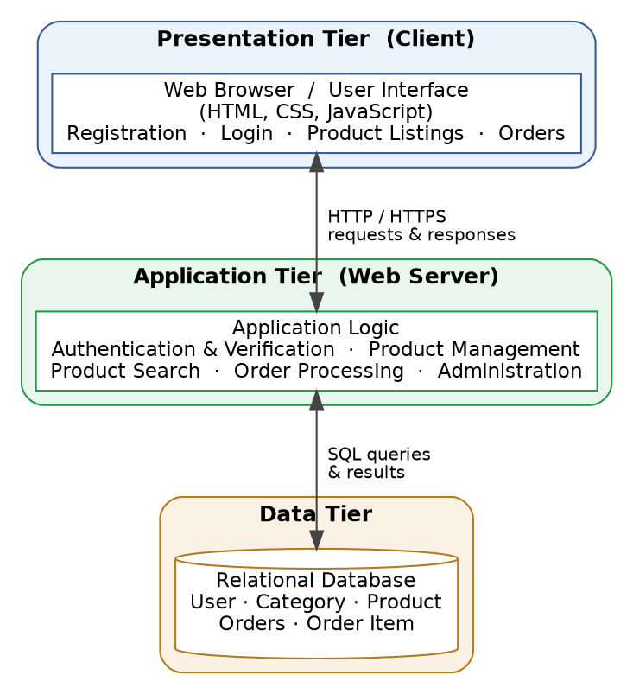
Figure 3.1: System Architecture (Three-Tier)

3.6.2 System Flowchart
The flowchart in Figure 3.2 depicts the overall flow of control through the platform, from a user's arrival to the conclusion of a transaction. A visitor who is not yet registered is required to create an account and to verify their institutional email address before logging in; once authenticated, the user reaches the home page, from which a seller may create and manage listings while a buyer may browse, search, and view products. When a buyer places an order, the system records it with an initial status of pending and makes it available to the seller, who updates its status as the goods and payment are exchanged in person.
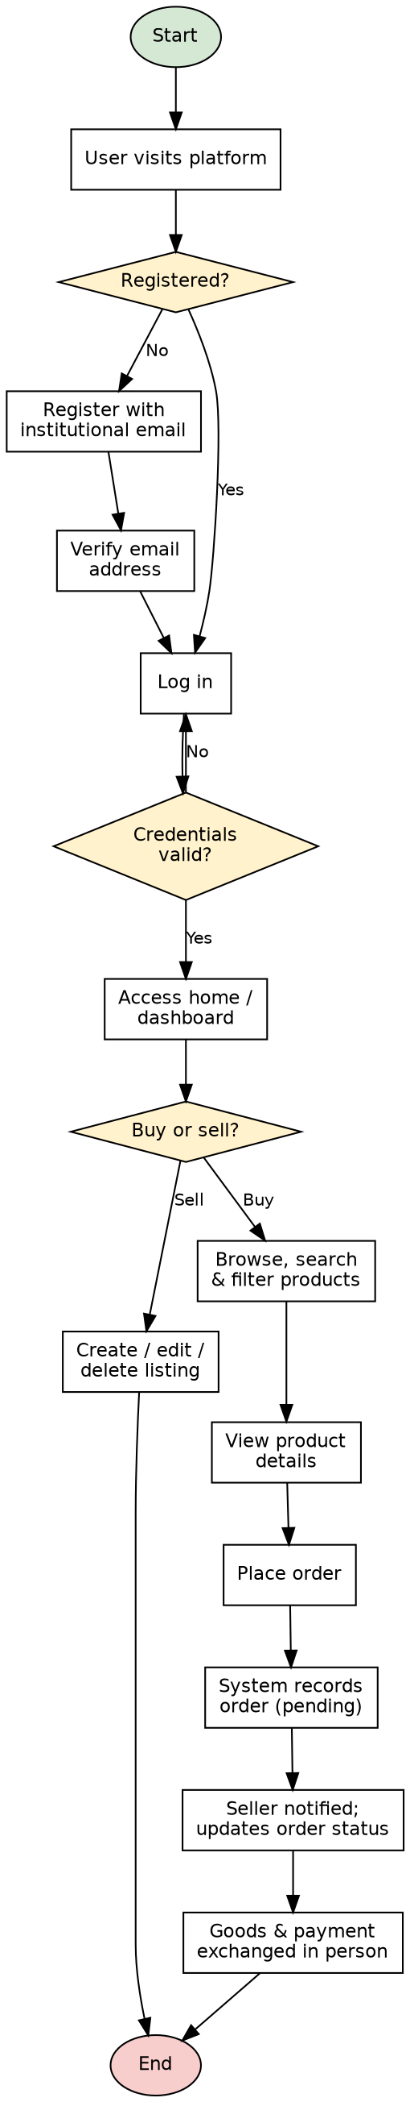
Figure 3.2: System Flowchart
3.7 System Design and UML Modelling
The structure and behaviour of the proposed system are specified using the Unified Modelling Language, a standard notation for modelling object-oriented systems. Three complementary diagrams are presented: a use case diagram, which captures the functions available to each type of user; a sequence diagram, which illustrates the interaction between system components over time; and a class diagram, which describes the static structure of the system in terms of its classes and their relationships.
3.7.1 Use Case Diagram
The use case diagram in Figure 3.3 identifies the actors who interact with the system and the use cases available to each. A general Web User is specialised, through a generalisation relationship, into a New Student, who registers and verifies an account, and a Registered Student, who logs in and then browses and searches products, views product details, places orders, and manages their own listings. An external Authentication Service supports the registration and login use cases by verifying the student's institutional identity, while the Administrator administers the platform, which includes managing users and categories and overseeing listings and transactions. The include relationships shown in the diagram indicate that placing an order necessarily involves both logging in and viewing the product's details.
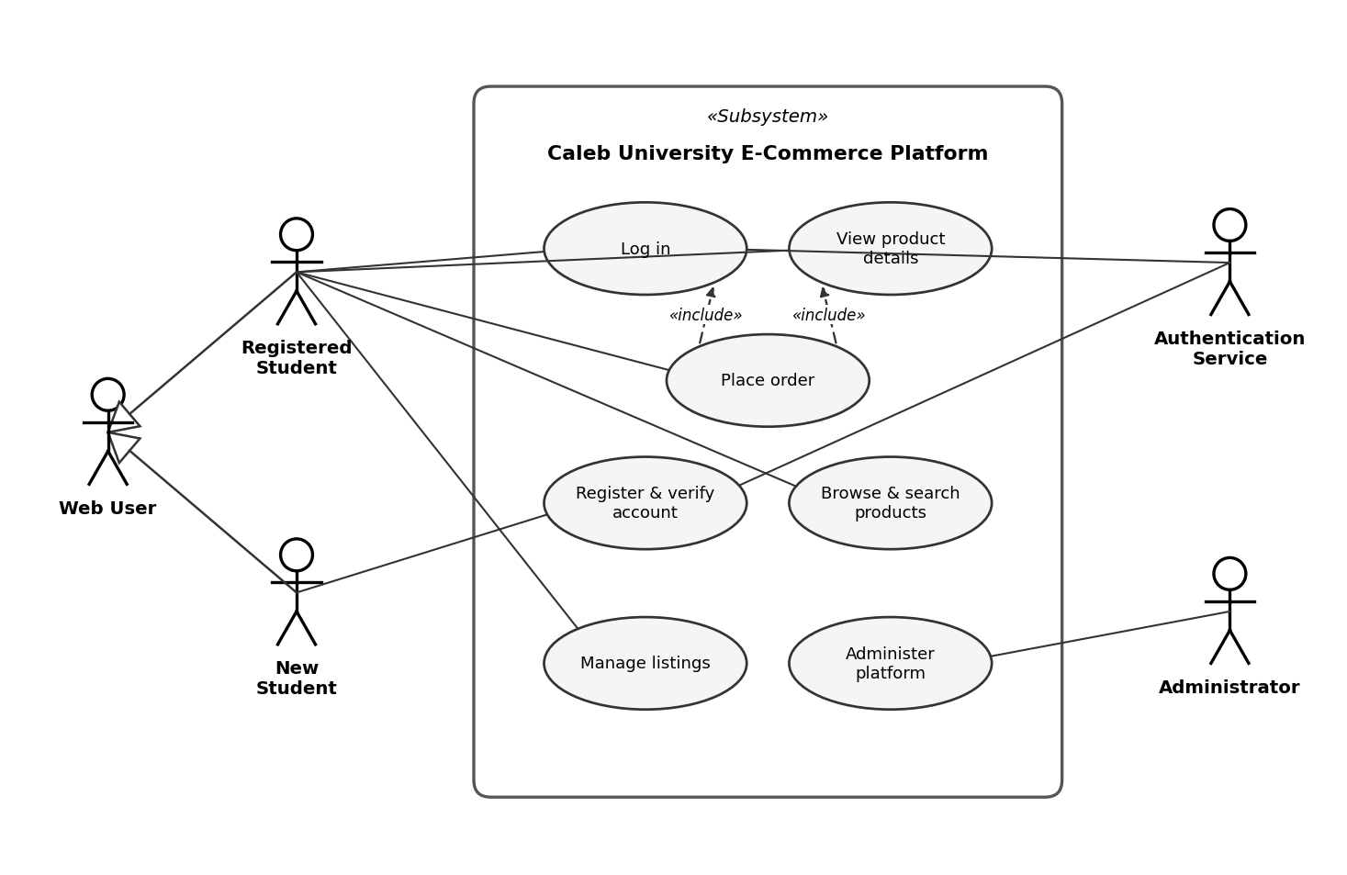
Figure 3.3: Use Case Diagram
3.7.2 Sequence Diagram
The sequence diagram in Figure 3.4 illustrates the interaction between the system's components across the principal activities a student performs, namely authentication, product browsing, and order placement. During authentication, the student submits their credentials through the web interface, which the application server validates against the user record in the database before establishing a session. During browsing, the student's search and browse requests are passed to the server, which queries the database and returns the matching products for display. During order placement, the student selects an item and confirms the order, whereupon the server stores the order and its associated items in the database and returns a confirmation with an initial status of pending. The dashed arrows in the diagram represent the responses returned to the student at each stage.
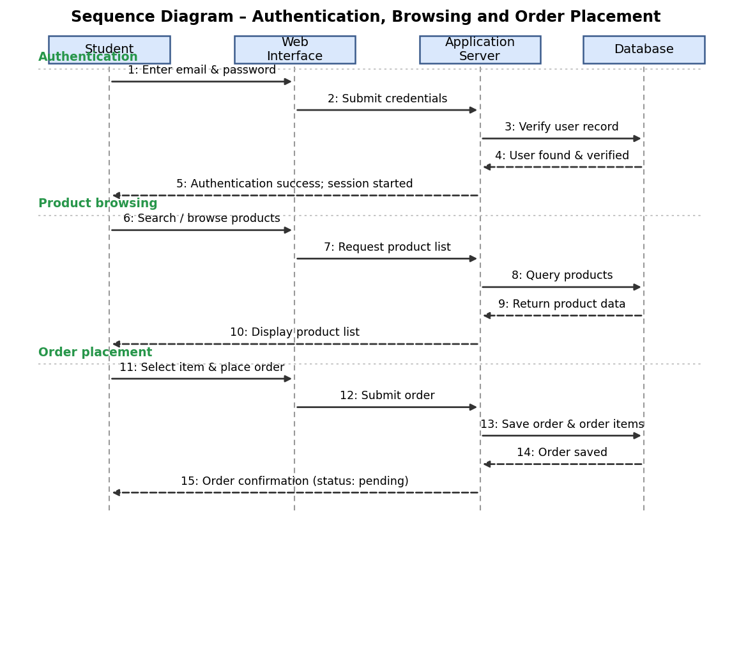
Figure 3.4: Sequence Diagram of the Main System Interactions
3.7.3 UML Class Diagram
The class diagram in Figure 3.5 describes the static structure of the system. The principal classes are User, Category, Product, Order, and OrderItem. The User class represents any registered member of the platform and holds attributes such as the user's name, email, hashed password, and verification status, together with operations for registration, login, and profile management. The Product class represents a listing and is associated with the User who lists it and the Category to which it belongs. The Order class represents a buyer's order and is composed of one or more OrderItem objects, each of which links an order to a particular product and quantity. The associations between the classes, together with their multiplicities, express the rules of the domain: a user may list many products, a category may classify many products, a user may place many orders, and an order may contain one or more order items.
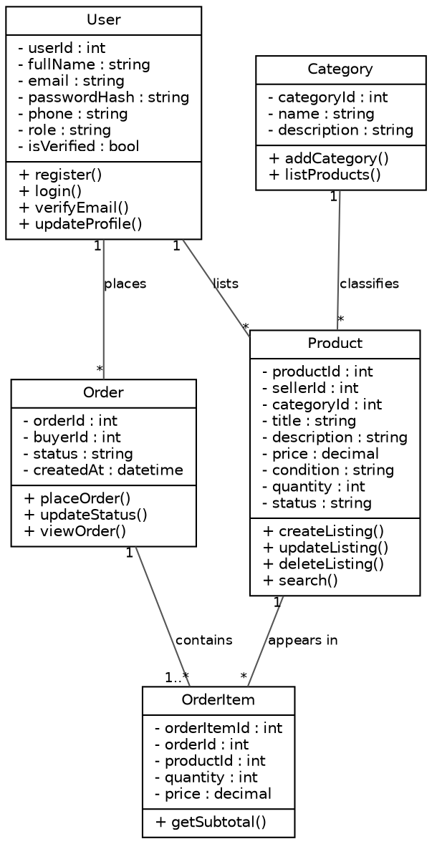
Figure 3.5: UML Class Diagram
3.8 Database Design
The persistent data of the platform is held in a relational database. This section presents the logical design of that database, first as an entity-relationship diagram showing the entities and the relationships between them, and then as a data dictionary giving the detailed definition of each field.

3.8.1 Entity-Relationship Diagram
The entity-relationship diagram in Figure 3.6 shows the principal entities of the database, namely User, Category, Product, Order, and Order Item, together with their attributes and the relationships between them. A user may sell many products and may place many orders; a category may classify many products; an order may comprise many order items; and a product may appear in many order items. The primary key of each entity is marked PK and the foreign keys that implement the relationships are marked FK.
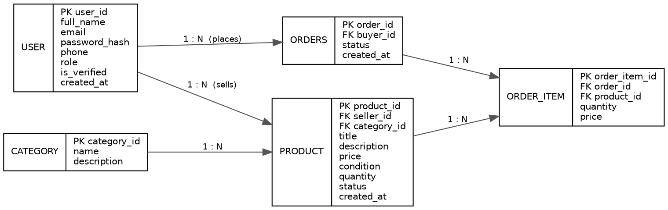
Figure 3.6: Entity-Relationship Diagram
3.8.2 Data Dictionary
The data dictionary defines each table of the database in detail, specifying for every field its data type, its constraints, and its meaning. The principal tables are presented below.
Table 3.1: User table
Field | Data type | Constraints | Description
user_id | INT | Primary key, auto | Unique identifier of the user
full_name | VARCHAR(100) | Not null | Full name of the user
email | VARCHAR(120) | Not null, unique | Institutional email address
password_hash | VARCHAR(255) | Not null | Hashed user password
phone | VARCHAR(20) | Nullable | Contact phone number
role | VARCHAR(20) | Not null | User role (buyer, seller, admin)
is_verified | BOOLEAN | Default false | Whether the email is verified
created_at | DATETIME | Default now | Date the account was created

Table 3.2: Category table
Field | Data type | Constraints | Description
category_id | INT | Primary key, auto | Unique identifier of the category
name | VARCHAR(60) | Not null, unique | Name of the category
description | VARCHAR(255) | Nullable | Brief description of the category

Table 3.3: Product table
Field | Data type | Constraints | Description
product_id | INT | Primary key, auto | Unique identifier of the product
seller_id | INT | Foreign key (user) | Seller who owns the listing
category_id | INT | Foreign key (category) | Category of the product
title | VARCHAR(120) | Not null | Title of the listing
description | TEXT | Nullable | Description of the product
price | DECIMAL(10,2) | Not null | Price of the product
condition | VARCHAR(20) | Not null | Condition (new or used)
quantity | INT | Default 1 | Quantity available
status | VARCHAR(20) | Default available | Listing status (available, sold)
created_at | DATETIME | Default now | Date the listing was created

Table 3.4: Orders table
Field | Data type | Constraints | Description
order_id | INT | Primary key, auto | Unique identifier of the order
buyer_id | INT | Foreign key (user) | Buyer who placed the order
status | VARCHAR(20) | Default pending | Order status (pending, confirmed, completed, cancelled)
created_at | DATETIME | Default now | Date the order was placed

Table 3.5: Order item table
Field | Data type | Constraints | Description
order_item_id | INT | Primary key, auto | Unique identifier of the order item
order_id | INT | Foreign key (orders) | Order to which the item belongs
product_id | INT | Foreign key (product) | Product ordered
quantity | INT | Not null | Quantity ordered
price | DECIMAL(10,2) | Not null | Price at the time of order

